***Custom Addresses Extension***

***Standard functionality :-***

When a user selects the shipping address or billing address in the checkout by default that address becomes default shipping or billing address in the netsuite customer record

The default shipping address and billing address is changes every time the user changes the address in the checkout

**What this extension does:-**

This custom address extension will stop the standard behavior and maintain the default shipping address and billing address based on the custom fields in the customer address subrecord

This extension enable the use this address as default shipping and use this address as default billing checkboxes for the every address in checkout when a user checks that box and updates the address that address will becomes default shipping address or default billing address based on in which section the user updated their address

After updating the address if the user selects / changes the address in the checkout either in billing or shipping does not affect the default addresses in customer record unless the user updates the address with (use this address as default) checkbox value as true. This extension maintains the default addresses based on the custom fields values in the customer address sub records

**Step 1:-** When user click/ select the address in the checkout that address is becomes default in customer record

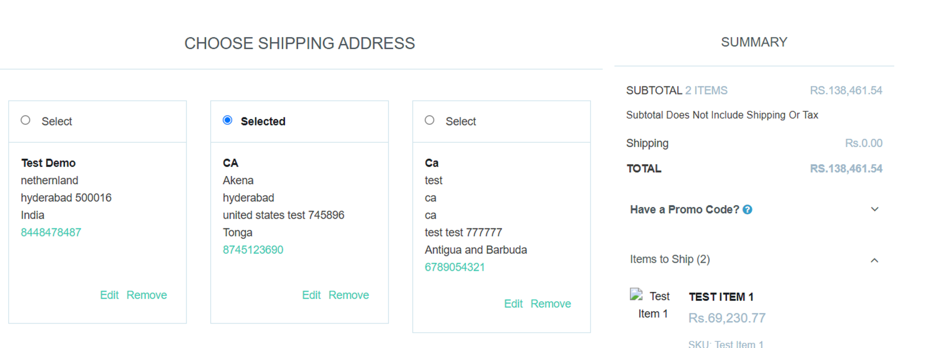

**.** After selecting the address in checkout that address will become default in customer record. This is standard functionality of the netsuite

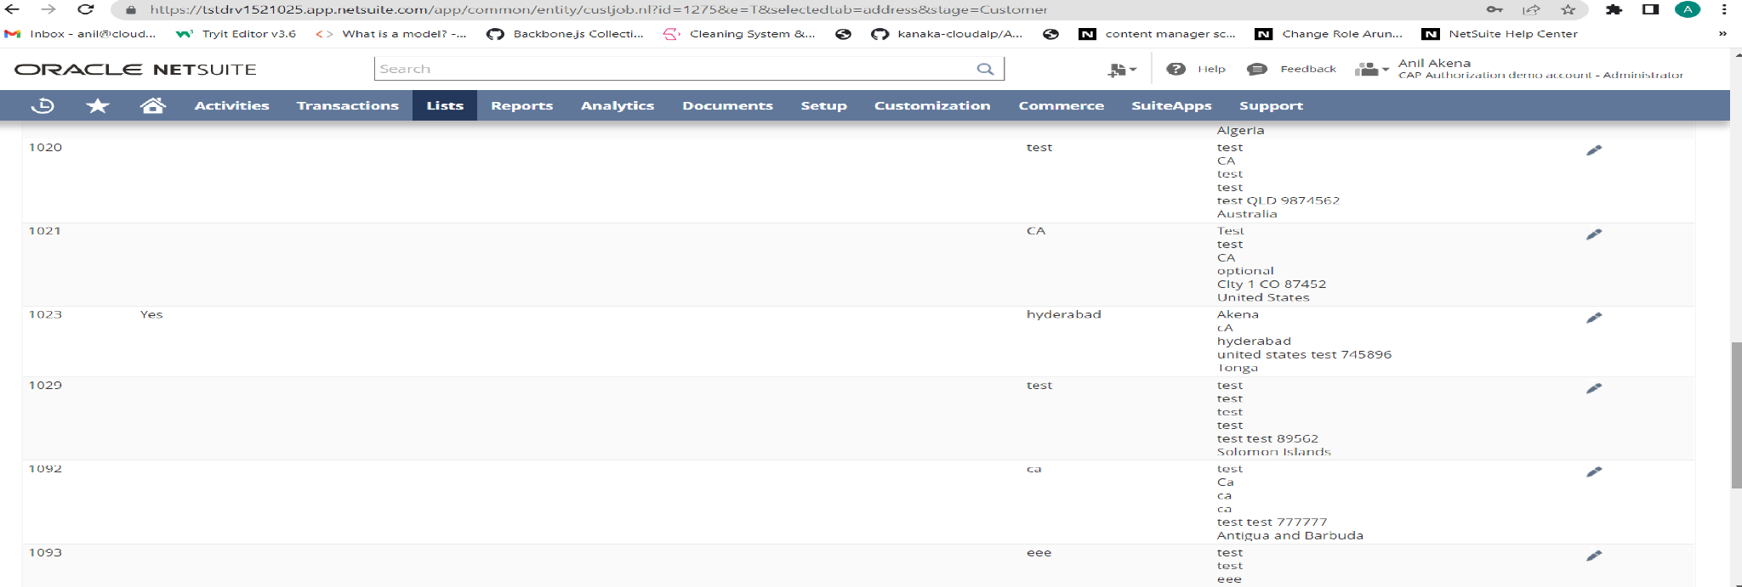

* Custom address extension enables a use this address as a default checkbox for every address in the checkout
* After clicking on edit button in address it will pop up a model in that model user will find the use this address as default button as shown in the below screenshot

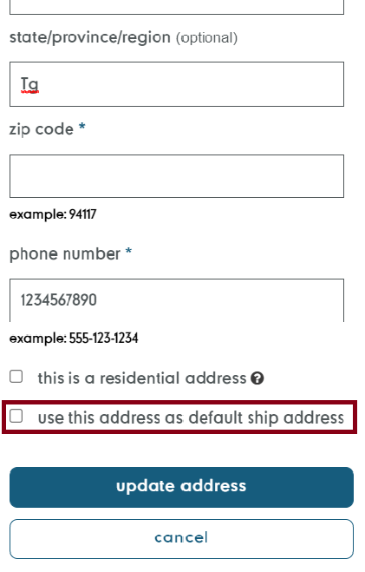

If the user updates the address by checking this checkbox then it will become the default address in the customer record 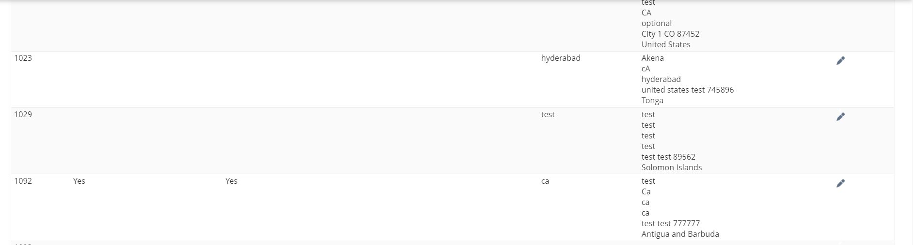

After this updation if the user selects the other addresses in checkout for the order that will not effects the default address in the customer record until and unless the user update the other address with the checkbox(use this address as default) value true

If the user select other address in the checkout for order

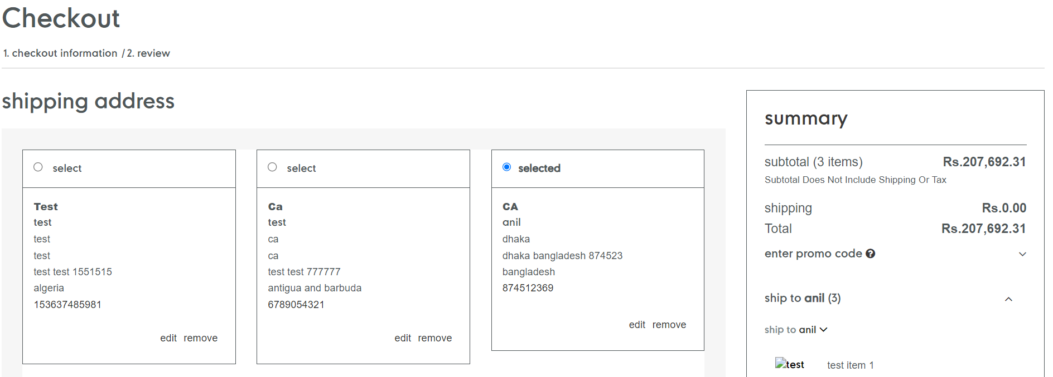

The default shipping address value in the customer record will not change



In the configuration there is a field available to define which Address functionality to stop (billing or shipping or both)

Test Cases :-

1. When the( custom Stop default shipping/ billing functionality ) configuration field value is shipping it will enable the (use this Address as default shipping Address) checkbox in the shipping Addresses and this checkbox will not appear in the billing Address section
2. When the configuration field value is billing it will enable the (use this Address as default billing) in the billing section and this checkbox will not appear in the shipping Addresses section.
3. When the configuration field value is both it will enable the (use this Address as default shipping Address) checkbox in the shipping Addresses section and (use this Address as default billing Address)checkbox in the billing Addresses section

Test Case 1:-

* if the value of configuration field is shipping it will enable the custom (use this address as default shipping Address) checkbox for every Address in the shipping Address Section in that case if the user updates an address by checking that checkbox then it will become the default shipping Address in the customer record and that Address is selected for the order.
* After that if user select or update other Address for that order the Default shipping Address is remain same in the customer record until and unless the user update other address by checking that custom checkbox in the Address
* If the user select other Address and update the default ship Address at that time default shipping Address is selected for that order
* When the user checks the custom checkbox field (use this as a default shipping Address) While adding Address it will selected for that address and it becomes default shipping Address in the customer record
* If the user deletes an selected Address (which is not default shipping Address) in the Shipping Addresses section then the default shipping Address will become the selected Address for that order
* After deletion of default shipping Address( which is selected) if user selects any other address for an order it will become the default shipping Address in the customer record.
* The (use this Address as default shipping Address) checkbox value is true if that Address is default shipping in the customer record

Test Case 2:-

If the configuration field (stop default shipping / billing functionality) value is billing then it will enables the use this Address as a default billing Address checkbox for every Address in the billing Addresses section

1. If a user updates an address by checking the (use this address as default billing) checkbox then that address will become the default billing Address in the customer record and selected as billing Address for current order.
2. After updating if the user selects or updates any other address in the billing Addresses section will not change the default billing address in customer record until and unless the user updates an address with (use this address as default billing) checkbox value as true.
3. If user deletes an address which is selected then the default address will selected for that order
4. If user delete an address which is selected and default shipping address then it will remove the default shipping Address from customer record
5. After deleting the default billing Address (which is selected) if user selects any other address that address will become the default billing address in the customer record
6. If user updates the default billing address that address will selected for current order
7. The custom field checkbox value is true if the Address is default in the customer record
8. If the user changes or selects any other Address in the shipping Address section that selected address will become default shipping Address in the customer.

Test Case 3:-

If the configuration field (stop default shipping / billing functionality) value is ‘both’ then it will enables the (use this Address as default shipping Address) checkbox for shipping Addresses and (use this address as default billing Address) checkbox for billing Addresses

1. If user updates an shipping address by checking the use this address as shipping Address checkbox that address will become the default shipping Address in customer record
2. If user updates an billing Address by checking the use this address as default billing Address that Address will becomes the default billing Address in the customer record
3. If user selects or update any address in shipping or billing Addresses will not change default ship and default bill Addresses in the customer record until and unless user updates use this address as default ship or default bill checkbox value as true
4. If user adds an address in shipping or billing section by checking the use this address as default shipping or billing Address checkbox that address will become the default ship or bill address in the customer record
5. If user deletes an address which is selected(nota default Address) in the shipping or billing section then default shipping or billing address will selected based on in which section it is
6. If the user updates default shipping or billing Address that address will be selected for that order.

Myaccount Addresses behavior

Regardless of configuration (stop default shipping / billing functionality) field value every Address in myAccount will show the (use this address as default shipping Address ) and (use this address as default billing Address) checkboxes

If user checks the( use this address as default shipping) checkbox while updating or creation of an Address then that address will become the default shipping Address in the customer record

If user checks the (use this address as default billing) checkbox while updating or creation of an Address then that address will become the default billing Address in the customer record.

